LEAP 3- Comparing and Contrasting Propaganda: Past vs. Present

Stephanie Cuozzo & Alyssa Cuozzo

Professor Renee Hobbs
COM 416

27, March 2017

The Power of Propaganda against & for Women

1970: Mr. Leggs Trousers
http://pzrservices.typepad.com/vintageadvertising/2007/05/mr_leggs_trouse.html

Though she was a tiger lady, our hero didn’t have to fire a shot to floor her. After one look at his Mr. Leggs slacks, she was ready to have him walk all over her. That noble styling sure soothes the savage heart! If you’d like your own doll-to-doll carpeting, hunt up a pair of these he-man Mr. Leggs slacks. Such as our new automatic wash wear blend of 65% “Dacron®” and 35% rayon–incomparably wrinkle-resistant. About $12.95 at plush-carpeted stores.
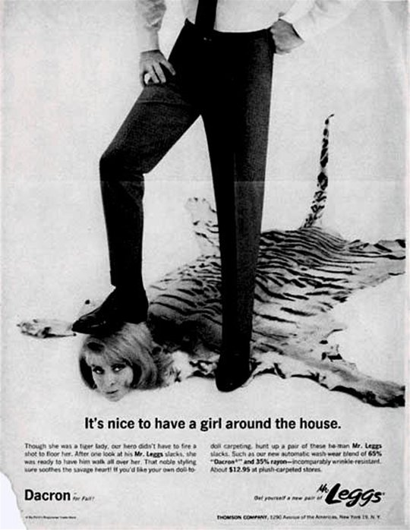
2013: King Khalid Foundation
http://www.huffingtonpost.ca/2013/04/29/king-khalid-foundation-violence-against-women-campaign_n_3177979.html

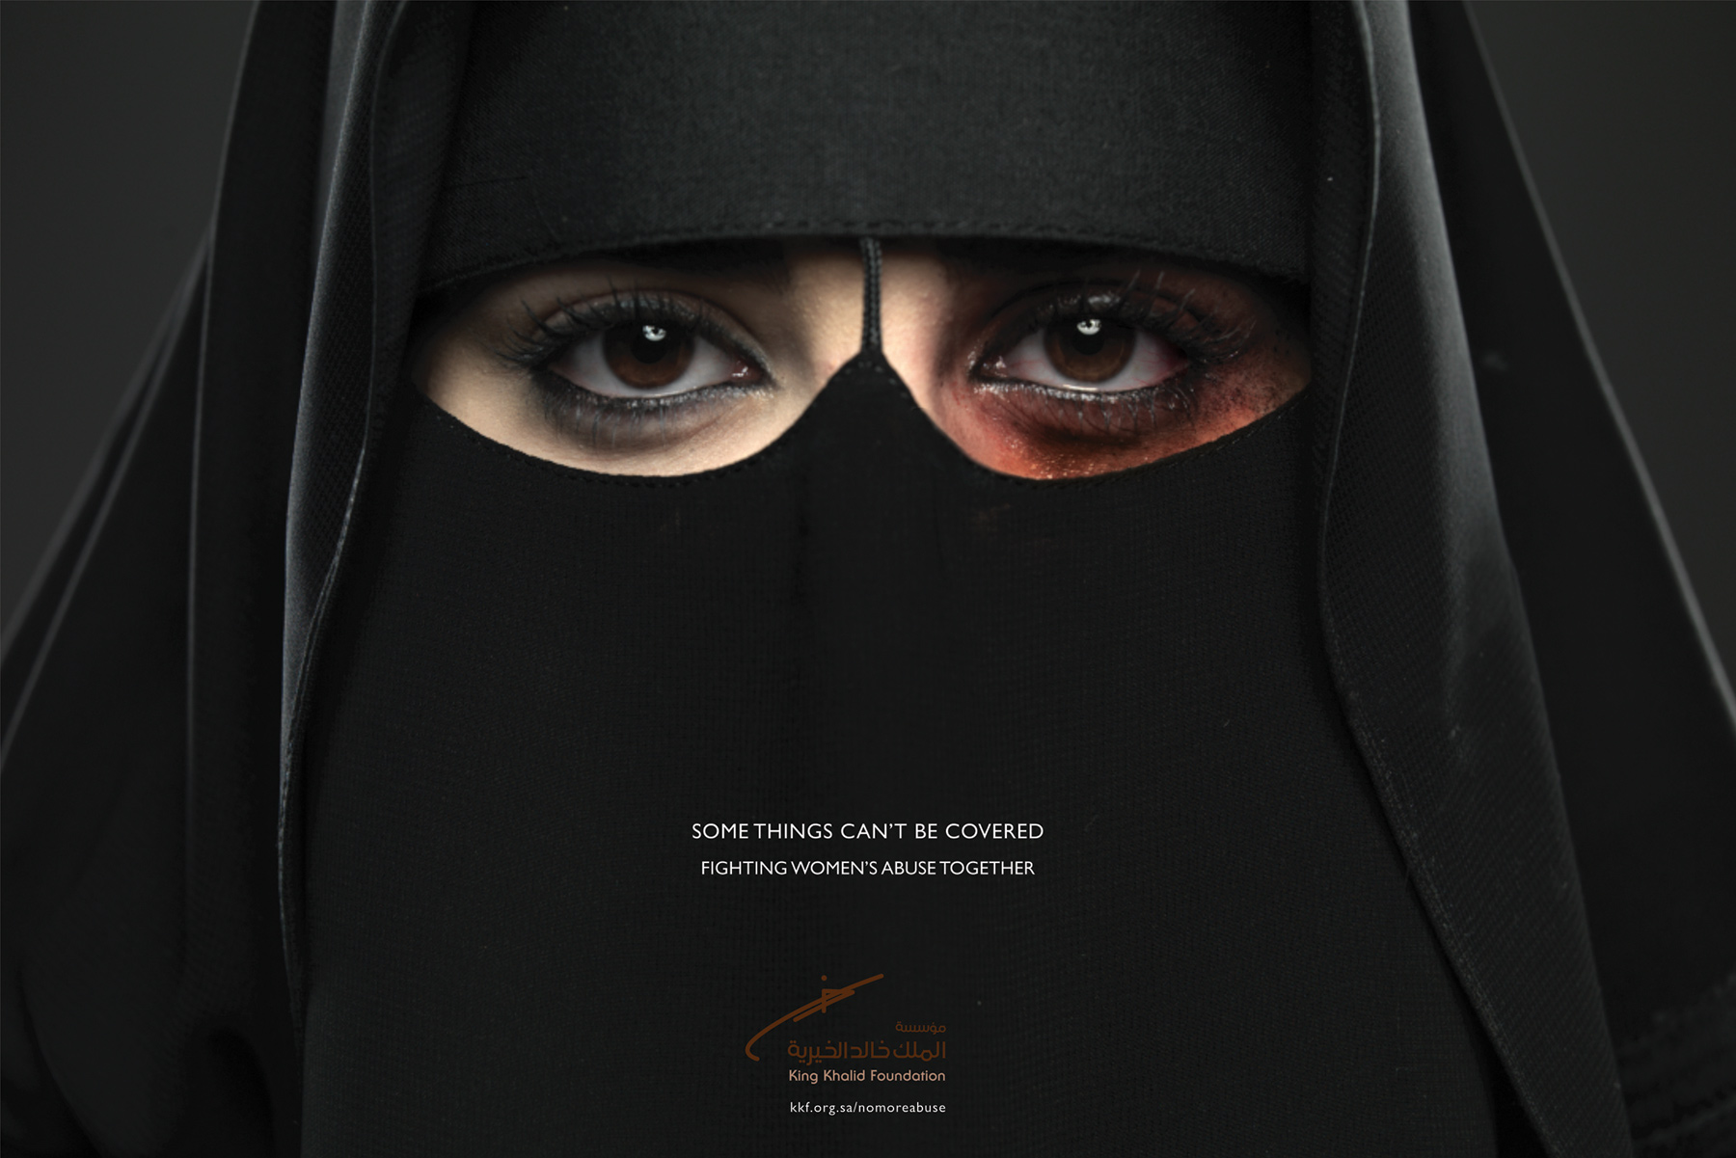

“Some things can’t be covered. Fighting women’s abuse together”

Abstract: In this essay, an analysis is conducted in order to understand the positive and negative portrayal/use of women in Propaganda comparing two advertisements-- one dated 1970 and the other 2013. The two specific pieces of propaganda are analyzed, compared and contrasted while referring to academic facts about propaganda and it’s purpose. Although the message of each advertisement are drastically different, they share a similar theme of controversial, emotionally provoking visual material.
Women have been a forceful minority since the beginning of time. Fortunately, each year that passes we see progress and improvement as women across the world become educated, employed and intelligently involved members of society. The stereotypes and gender norms that defined and molded many women in past decades are now fading away with each new generation as more and more women are following alternative paths and are refraining from the pressures of motherhood and marital commitments. Much like the evidently powerful force of patriarchy that society has deemed normal, a similar force has held a grasp on our culture for centuries. That force is Propaganda.
In “Propaganda Power and Persuasion” author David Welch explains just how the influence of Propaganda entered our culture in the 20th century. Although Propaganda has been apart of society for thousands of years, the world was truly able to see the effects when “the development of mass media (and later multimedia communications) offered a fertile ground for its dissemination.” (Welch 2) Mass media is an extremely powerful tool that is used to persuade and convince the minds of millions, and willingly we conform to the molds it provides. In the late 1960’s into the 70’s, The Women’s Rights Movement was beginning to gain power in the United States. Famous feminist leaders like Gloria Steinem and Kate Millet were gaining public attention, both positively and negatively, for their literary works and public activism. As a clear majority of men and women began to follow this movement, many disproved of feminist beliefs and fought to keep women in the structures and norms that the patriarchy worked so hard to build.
In the year 1970, a company by the name of Mr. Leggs released an ad to promote their new men’s trousers. The ad shows a man's lower half, placing one foot onto the head of a woman whose body appears to be the skin of a tiger. Her eyes look up at him, as his shoe presses on her hair and his knuckles press against his hip, in a very strong fashion. The first line reads, “Though she was a tiger lady, our hero didn’t have to fire a shot to floor her.” Over the years the advertisement has been analysed and discussed by many, but considering the era in which the ad was released, perhaps the “tiger lady” represents a woman with feminist beliefs. Naturally, “our hero” is the well dressed male who so effortlessly “floored her.” The next line reads: “After one look at his Mr. Leggs slacks, she was ready to have him walk all over her.”
Interestingly enough, after this “tiger lady” took just one look at this male in his “Mr Leggs slacks” she was no longer a fierce tiger lady, yet a floor mat ready to be stepped on. The company’s target audience was clearly specific. Perhaps the goal was to anger feminists and empower men through humor and satire.
In Edward Bernays’ 1928 Propaganda, we are able to see a powerful point that relates to the issues presented above. He writes: “Our attitude toward social relations, toward economics, toward national and international politics, continues past attitudes and strengthens them under the force of tradition.” (Bernays, Chapter IX) The power of tradition has benefited and crumbled our society simultaneously. Tradition leaves no room for improvement or change-- two things the women’s movement needed most. Propaganda plays heavily with tradition because propagandist know the power it holds over the majority of society.
Now we are living in the 21st century. Advertisment like Mr. Leggs Trousers are seen as immoral and unthinkable. Women hold a much higher position in society and the improvements in everyday life are astounding. These improvements do not mean we should settle and not push for more. Feminism still holds a negative connotation among some and power imbalance within marriage is still an ongoing issue within partnerships across the globe. Domestic abuse is one issue that has unfortunately remained present during this process of reaching equality. Much like the power imbalance we see within the 1970 trouser ad, areas of the world are still dealing with a similar type of patriarchal grasp. In 2013, the Saudi Arabian organization King Khalid Foundation released an ad for their anti-domestic violence campaign. In the recent year of 2013, Saudi Arabia made domestic violence a criminal offense with punishments such as fines and prison sentencing. In 2016 alone, Saudi courts received 1,498 reported domestic violence cases. (S.G) The efforts of foundations like King Khalid have tirelessly attempted to fight for a cause that has been instilled in culture and tradition. The 2013 ad shows a woman wearing traditional niqab headscarf with piercing eyes, one badly bruised. The image alone needs no description, but very simply beneath her face reads: “Some things can’t be covered. Fighting women’s abuse together.”
“In Saudi Arabia, a woman’s life is controlled by a man from birth until death.” (HRW) Every Saudi woman must have a male guardian. That being her father, husband or even a son that makes decision on her behalf. “Women in Saudi Arabia are required to have a “male guardian.” This is not an official legal requirement, but a pervasive social one”. (C.Sue) Many Saudi women have told the Human Rights Watch, that the male guardianship system has become a hindrance in realizing women's rights. This campaign raises awareness against domestic abuse in efforts to embrace some civil rights reform. This eye opening campaign raises concerns not only in Saudi Arabia but also in the United States. Although, women in the United States have fought for Women's Right’s for years and have seen these improvements progress, the woman in Saudi Arabia have only seen slow changes in their rights.
Although the image of this young Saudi woman is disturbing it is untimely effective. It raises questions regarding the issue of woman’s rights and the truth behind domestic abuse. The image is raw and honest, which is exactly why it is an effective piece of propaganda. The issue surrounding the campaign is negative but the campaign itself brings positivity and hope that one day women will receive justice for these wrongdoings and gain the rights they deserve.
When looking at both of these pieces of propaganda it is apparent which one is positive and which one is negative. In comparison, both show signs of abuse but then again both stand for different reasons. The Mr. Legg’s ad from 1970 is merely a sexist advertisment that incites male power. This negative ad degrades women and implies that in these slacks, she will be ready for you to walk all over her. To some this is just a humorous ad but realistically it is offensive. It truly defines the time era this ad was created in. Thinking back to the early 1970’s men would have found this ad appealing given the inequality and lack of women's rights. The ad associates the product with dominance and strength. There is more to this ad than what meets the eye. The marketing tactic used to sell the product is desire and that women will fall for any man that wears these trousers, perhaps suggesting that women are pushovers. These assumptions reinforce stereotypes because again, they are suggesting that men are superior and women are submissive.
Jumping to the 21st century and viewing this ad for the King Khalid Foundation strikes emotion on the audience. The campaign is designed to help women receive justice against domestic violence and also raises the question on women’s rights in Saudi Arabia. The photo of the Saudi Arabian woman is powerful and persuasive. Her piercing eyes scream fear and her bruise defines the horror of abuse. The topic of domestic abuse is definitely not positive but the campaign behind the issue is. The ad was strategically designed to impact the viewer. “Depiction of an identified individual victim appears to be highly emotionally evocative and this may motivate distress and, consequently, donations”. (Kogut and Ritov, 2005) There are many educated women in today’s society, it is important to recognize that what was happening in the 1970’s, as far as abuse and women’s rights, is far worse than what is happening in Saudi Arabia.
As mentioned earlier, perhaps the goal of the the Mr.Leggs ad were to anger feminist and create agitation. “Agitation propaganda seeks to arouse people to participate in or support a cause. It attempts to arouse people from apathy by giving them feasible actions to carry out”. (G. Jowett, 271) Agitation propaganda also suites the King Khalid Foundation ad because it sparks outrage within a specific audience.
A Propagandist always has an agenda to appeal to-- but it may not always be in a negative way. In WWII we are shown a new level of propaganda, where the public was manipulated and deceived. For reasons such as these, propaganda as a whole adapted a highly negative connotation. According to the American Heritage Dictionary, Propaganda is defined as “The systematic propagation of a doctrine or cause or of information reflecting the views and interests of those advocating such a doctrine or cause.” There is no indication of whether this systematic propagation holds a definite negative or positive undertone. We as society have contorted the use and natural meaning of propaganda into a manipulation tactic. The advertisement piece put forward by the King Khalid Foundation is a perfect example of positive propaganda-- the foundation is simply “advocating a doctrine or cause”, thus creating propaganda. In this case, the cause that is being advocated for is a bold attempt to stop violence against women, and the emotional provoking image of a badly bruised woman is a perfect example of visual material used in propaganda. In The Power of Visual Material: Persuasion, Emotion and Identification, author Helene Joffe analyses the use of visual material within the world of persuasion. Joffe writes: “ Visuals are used not only to illustrate news and feature genres but also in advertising and campaigns that attempt to persuade their target audiences to change attitudes and behaviours.”(Joffe 84) When we look at the woman staring back at us in the ad, we are meant to feel something. The goal is to reach us on an emotional level and push us toward changing our attitude--perhaps donating money, becoming an advocate or educating others about domestic abuse in Saudi Arabia. The goal with visual imagery is not for you to move on with your day and forget what you saw, the goal is to strike you and impact you emotionally in order to persuade you or change you in some way.
In the 1970 Mr Leggs ad, visual material is also used but in a much more disturbing way. The image of the man actually stepping on a woman’s head is not only condoning a demeaning and sexist message, it causes controversy-- and the public loves controversy. When a company releases a controversial ad, they know exactly what they are doing. Whether it be in a negative or positive way, the ad gets people talking. It causes debate and conversation amongst the public-- and as the old saying goes “there’s no such thing as bad publicity”. In any case, Mr Leggs received attention and most likely a spike in sales after this ad was released, even if people were bothered by it. Joffe explains how the use of imagery is even more powerful than text when she states, “while one might argue that debate is inherently verbal/textual, one could juxtapose images and leave people to ‘read’ the controversies for themselves.” (Joffe 85) Due to the fact that we all think and process information differently, imagery is one of the most powerful tools out there-- especially for propagandist. Images are used in advertisement to brew thoughts in our minds and leave us question the meaning or message hidden within.
Both pieces of propaganda are controversial, but for different reasons. Women as a whole have been so forcefully placed in a molded position by society to the point where controversy inevitably follows. Not only is domestic abuse somehow a controversial topic to discuss and address, the idea of a woman standing her ground against her abuser is even more contentious. The King Khalid ad uses both of those issues and captures our attention. The line “some things can’t be covered. Fighting women’s abuse together” then ads an immense amount of scandal to the message. Factually speaking, women in Saudi Arabia who follow the traditional religious practices of Islam are expected to cover their bodies in an effort to abstain from posing as a distraction for men. Within the ad, the foundation uses the fact that women are expected to dress modestly as more or less a tool used by abusers in an effort to hide marks and bruises. Religion alone is a very controversial topic, and personally speaking, each and every person is free to believe and practice any form of belief that they please. The King Khalid ad takes that controversy (that we have manufactured ourselves as a society) and gambles with it.
There is a clear understanding of the positive and negative portrayal/use of women in propaganda when comparing these two advertisements. One advertisement from 1970 and the other from 2013 were analyzed, compared and contrasted. It is understood that both pieces of propaganda are controversial but, for different reasons. Both ads pertain to women but the issues behind the ads touch upon different concerns. The Mr. Leggs ad from 1970 is a sexist message that reinforces stereotypes about gender identity. It goes to show that today, in the 21st century this behavior is recognized as immoral and unacceptable. The King Khalid ad from 2013 defines the issue behind domestic abuse and the injustice Saudi Arabian women receive. This forty-three year gap has proved that certain areas of the world are still dealing with women’s inequality.

Work Cited

Bergeron, Ryan (2015) CNN “The Seventies: Feminism makes waves” Obtained from: CNN- Feminism makes waves

Bernays, Edward (1928) Lg Publishing “Propaganda” New York

Joffe, Helene (2008) The Power of Visual Material: Persuasion, Emotion and Identification.
Diogenes 217: 84 – 93

Jowett, Garth & O’Donnell Victoria (2005) How to analyze propaganda

Welch, David (2013) “Propaganda Power and Persuasion” The British Library. London

King Khalid Foundation

http://www.cnn.com/2013/09/02/world/meast/saudi-arabia-domestic-violence/

http://english.alarabiya.net/en/variety/2016/03/02/Domestic-violence-cases-on-the-rise-in-Saudi-Arabia.html

Human Rights Watch
https://www.hrw.org/report/2016/07/16/boxed/women-and-saudi-arabias-male-guardianship-system
National Geographic
https://blog.education.nationalgeographic.com/2013/05/03/saudi-arabia-launches-powerful-campaign-against-domestic-violence/

